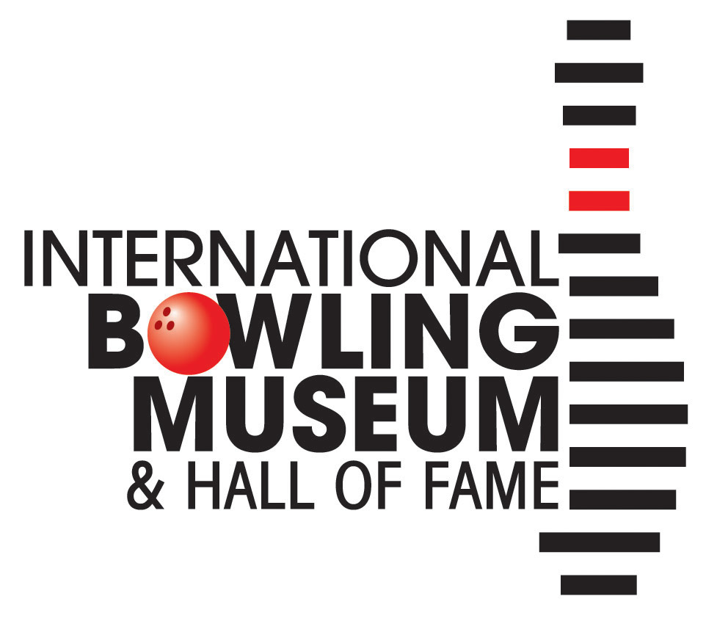

School/Youth Organization Tour Reservation

Forms can be emailed to Kari Smith, group tour coordinator, Kari@bowlingmuseum.com or faxed to 817-633-2940. We request that tours be booked at least two weeks prior to your visit. Admission for School/Youth Organization Programs is $5.50/youth (18 and under) with one adult chaperone admitted for every five youths. Payment is required on the day of the tour in cash, check, or credit card. Funding is available for organizations that would have difficulties paying these fees.

Requests for more information, questions, or concerns can be directed to Kari via email or phone 817-385 -8230. Thank you for taking the time to complete this form and we look forward to your visit!
School or Organization Name:
Address:
Contact Person:
Email:
Phone:
Alternate Phone or Email:

Desired Date of Visit: Click here to enter a date.
Museum Hours, Tuesday – Saturday 9:30am – 5pm

Preferred time: ☐Morning ☐Afternoon (latest start time 3:00 pm) ☐No Preference

Number of Students/Youth:
Age/Grade Level:

Number of Adults, accompanying group:
*1 Adult Chaperone admitted per 5 youth, 1 Adult chaperone required for every 10 youth attending. Additional Adults will be charged $5.50 to attend with group.

Additional Requirements (please list any special needs here):

Will you be applying for funding for your visit? ☐Yes ☐ No
*If applying for funding, please complete the attached Funding Request form

Funding Request
The International Bowling Museum and Hall of Fame is proud to offer funding for organizations and schools serving low-income youth to visit the museum at low or no-cost. Regular youth admission is $5.50 and adult admission is $9.50.

Completed forms can be emailed to Kari Smith, group tour coordinator, Kari@bowlingmuseum.com or faxed to 817-633-2940.

Requests for more information, questions, or concerns can be directed to Kari via email or phone 817-385-8230. Thank you for taking the time to complete this form and we look forward to your visit!

Name of Organization/School:

Contact Person:
Email:
Phone:

Desired Date of Visit: Click here to enter a date.

Number of Youth (18 and under):

Number of Adults, accompanying group:
*1 Adult Chaperone admitted per 5 youth, 1 Adult chaperone required for every 10 youth attending. Additional Adults will be charged $5.50 to attend with group.

Are you a nonprofit organization? ☐Yes* ☐No
*Please attach an IRS Determination Letter or other proof of nonprofit status.

Has your organization visited the IBMHF before? ☐Yes ☐No
If so, approximately when?

Are you requesting full-funding or partial-funding for your group?
☐Full funding; youth admitted at no-cost to your organization.
☐Partial Funding; $2.50 admission per Youth

Would your group be unable to visit the museum if only awarded partial-funding? ☐Yes ☐ No

Additional Information:

