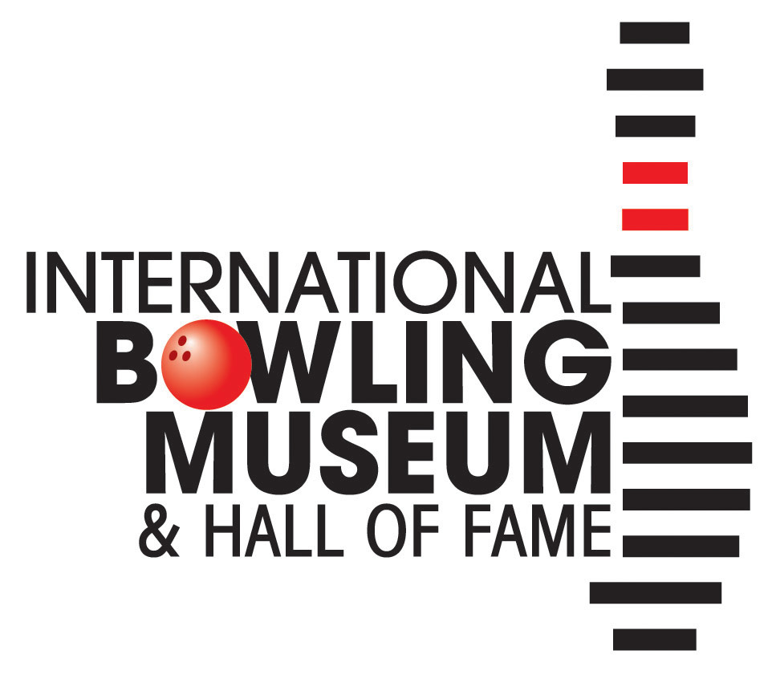

Group Tour Reservation

Forms can be emailed to Kari Smith, Group Tour Coordinator, Kari@bowlingmuseum.com or faxed to 817-633-2940. We request that tours be booked at least two weeks prior to your visit. Admission fees per ticket: Adult $9.50, Seniors/USBC/BPAA members $7.50, Youth (18 and under) $5.50. Payment is required on the day of the tour in cash, check, or credit card. Reduced rates available for large groups, please contact for pricing.

Requests for more information, questions, or concerns can be directed to Kari Smith via email or phone 817-385 -8230. Thank you for taking the time to complete this form and we look forward to your visit!
Contact Person:
Email:
Phone:
Alternate Phone or Email:

Desired Date of Visit: Click here to enter a date.
Museum Hours, Tuesday – Saturday 9:30am – 5pm

Preferred time: ☐Morning ☐Afternoon (latest start time 3:00 pm) ☐No Preference

Number of Total Visitors:
Are you a bowling league or USBC members? ☐Yes ☐ No
If yes, where?

Number of Youth Visitors:
Age of Youth:

Number of Adults:
Number of Seniors:

Additional Requirements (please list any special needs here):

